Radio Station Banner

Set up document. Lanuch illustrator, go to Edit>Preferences>Units and change “general” to pixels.

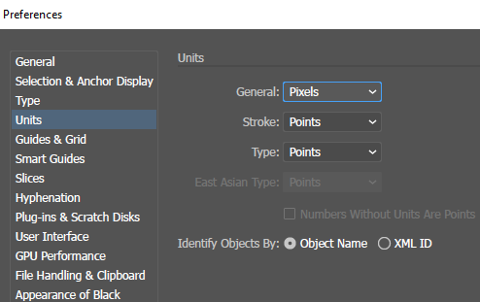

File>new>web and customize the document with the settings in image below:

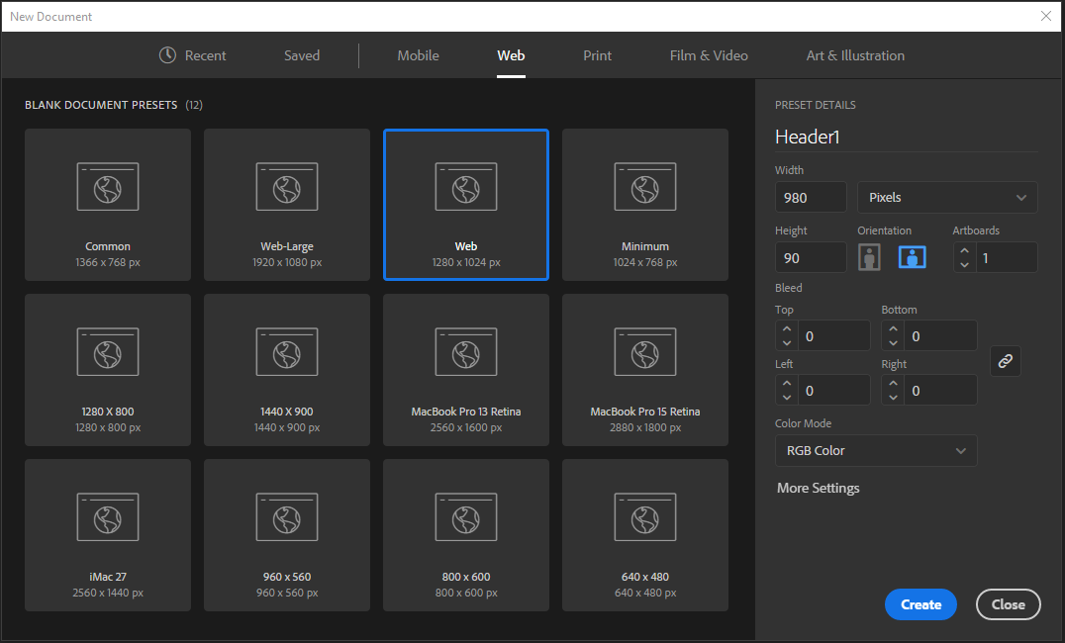

View>Rulers>Video Ruler and View>rulers>show rulers.

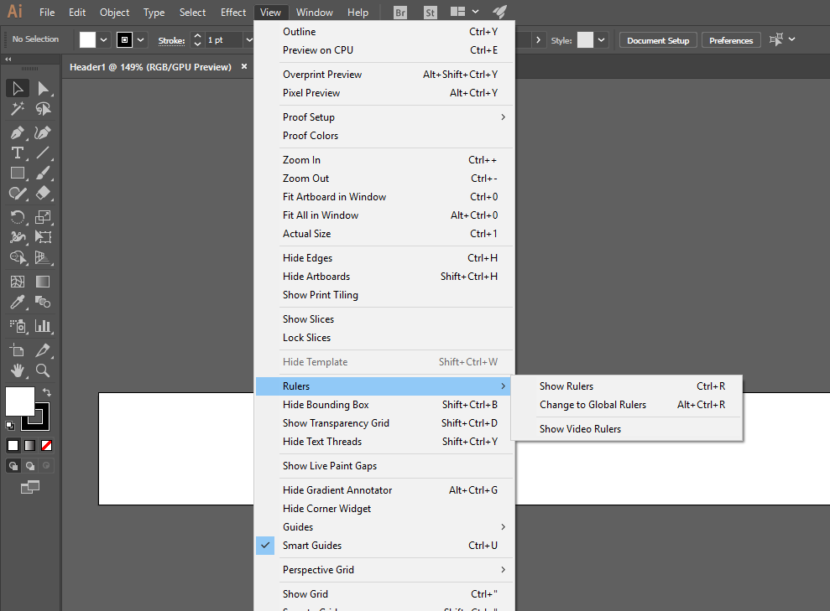

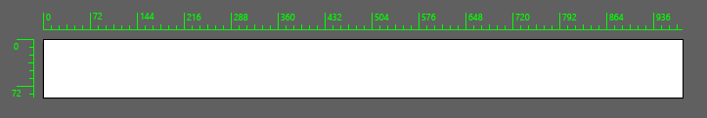

Start to create the rectangle for banner with the square tool and settings in image:

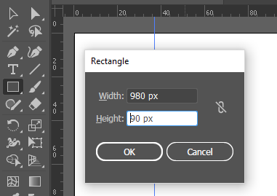

Select Window>Gradient to display gradient panel. Choose color like in image below:

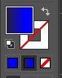 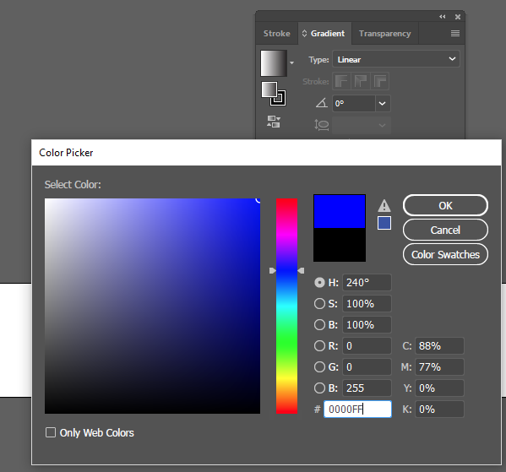 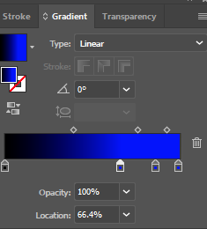

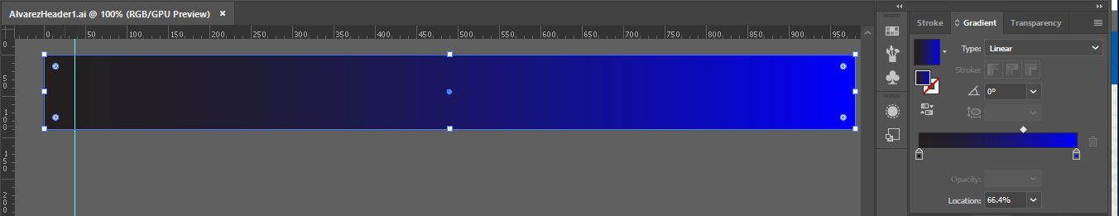

Select File>Place>Rock.jpg image. Make sure Link and Template is Unchecked for this portion.

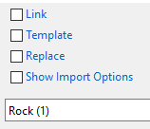 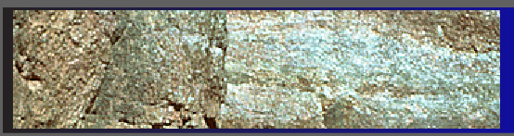

Select Type Tool and click on image. Use black Fill and Stroke None. Choose whatever font and size (48 for ROCK 99.2 and 24pt for WABW).

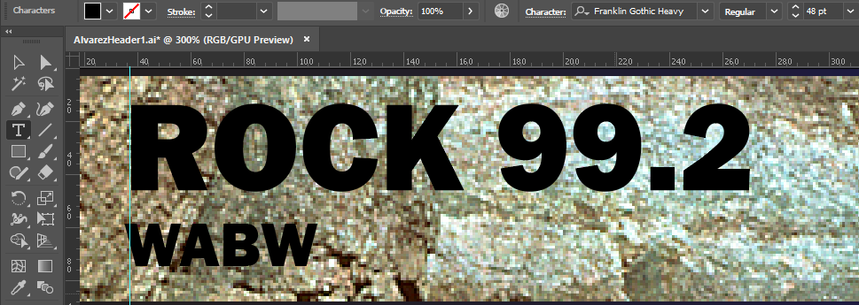

To combine text and image – hold type with selection key V then hold shift bottom and with selection key (V). Go to Object>Clipping Mask>Make.

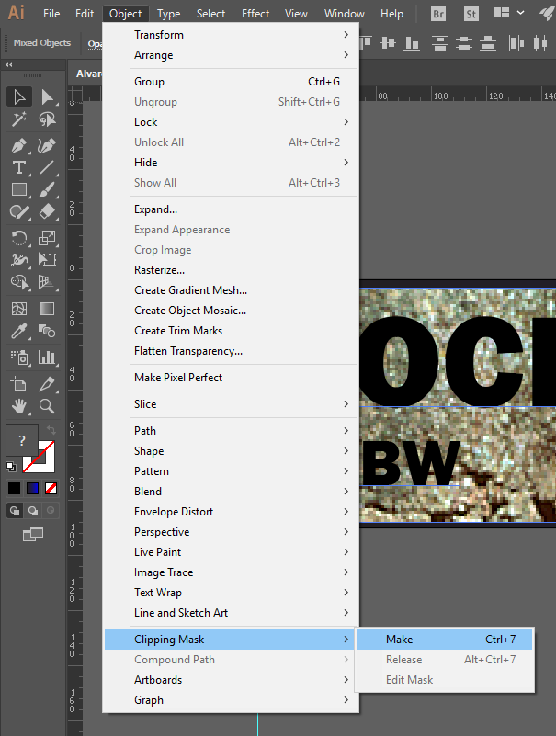



Touch type enables to work with letters or characters. Select the Type tool and choose Touch Type Tool and select Letter “R” to rotate as individual objects and change the size. Note: click on the top circle to rotate.

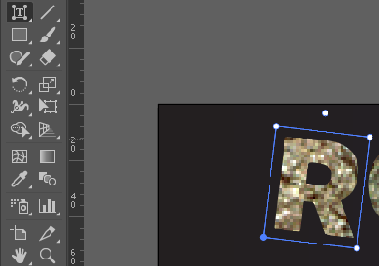

Photoshop portion of exercise:

* Launch Photoshop and open Guitars.jpg image and crop the desired guitar

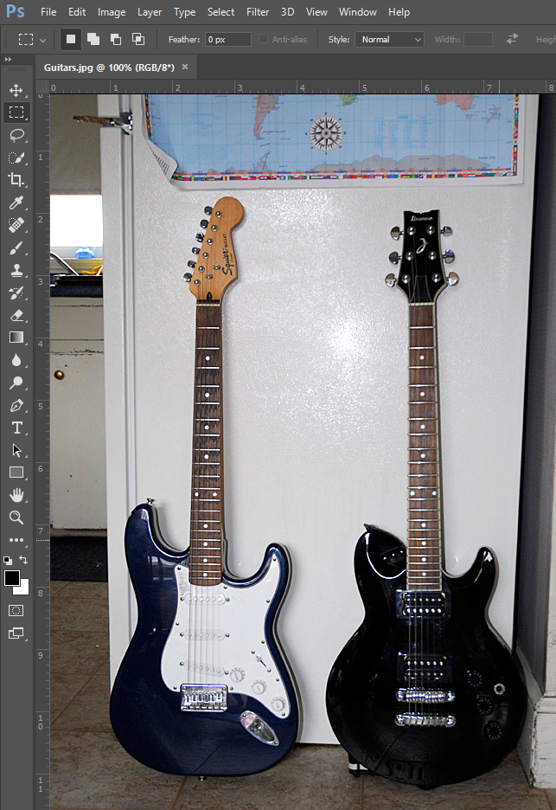

Go to Window>Layers. The Guitar has two layers as below: and drag the Background layer into trash icon. If background is still displayed, use Magic Eraser Tool (E) with tolerance 5 or 10 px and click the background area.

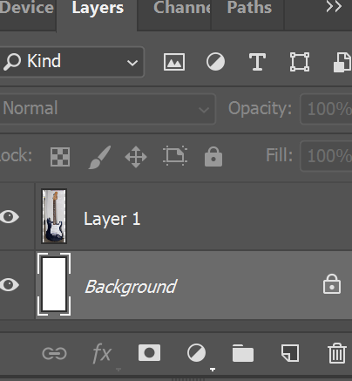

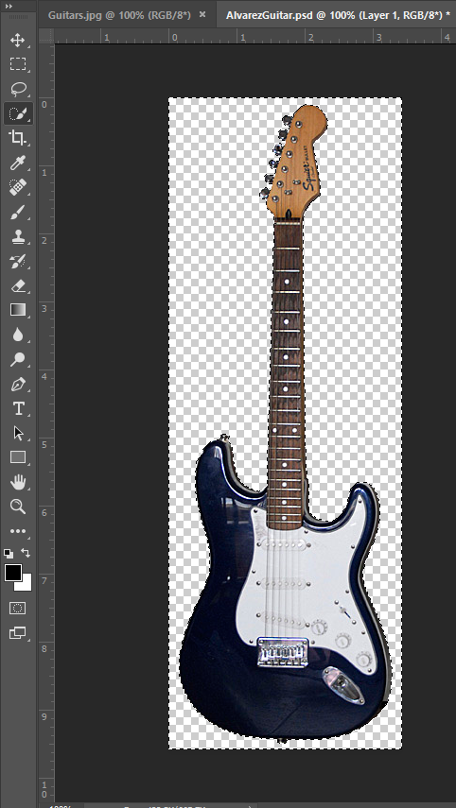

Use Quick Selection(W) at 10 px and create a selection that stays outside the guitar image in accurately.

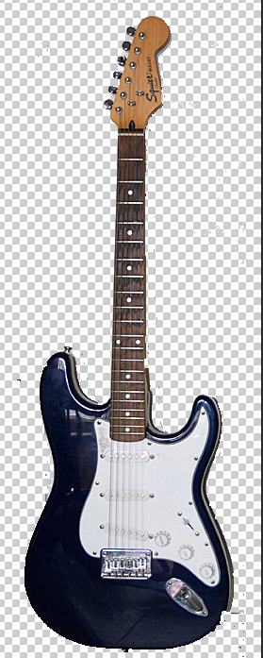

* To make a red glow around the guitar, click the Layer Style (“fx”) icon at the bottom of the layer panel, and select the Outer glow style.

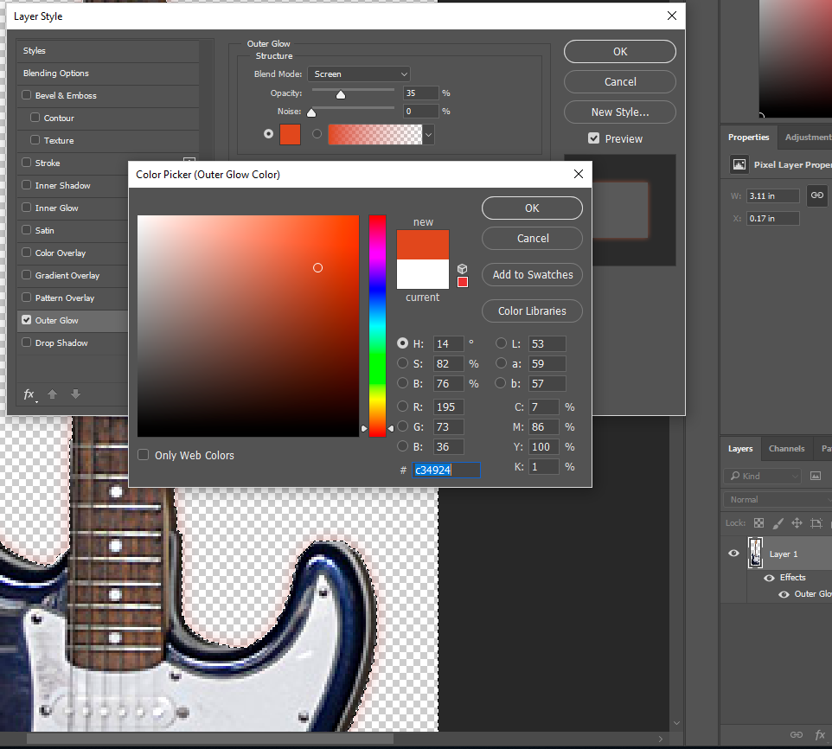

In the Layer Style box, click the color box next to Gradident bar to display color. Select orange red color and custom other box as below:

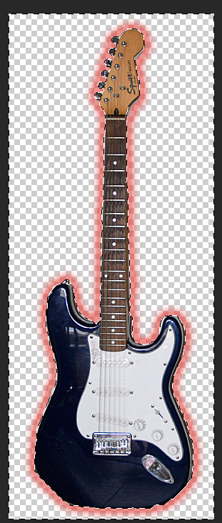 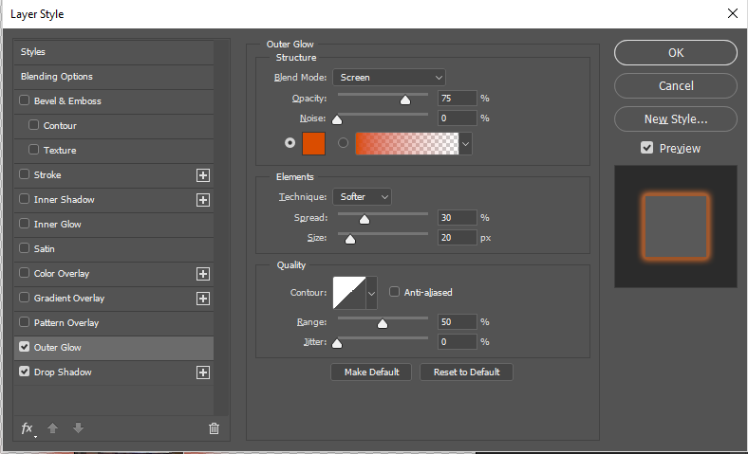

Use Eraser Tool (E) with small brush to remove stray background or shadow. And save when you are satisfied.

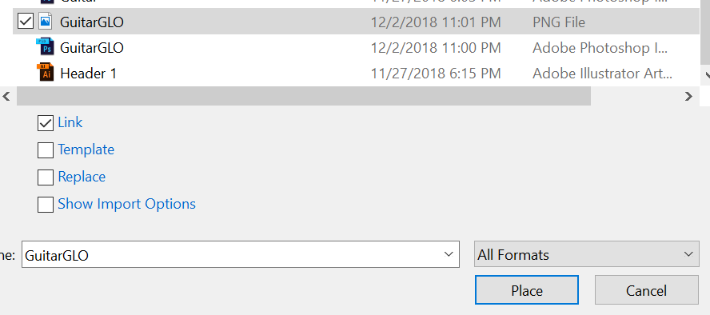

Go back to Adobe illustrator with Header1.ai document and zoom 100%. Select File>Place GuitarGLO.png file that we just created in Photoshop. Leave link option checked to provide a link in case you need to make changes to the guitar image later.

Drag guitar image right side with selection key (V) in the web header. Then go to Object>Transform>Rotate>-80 degrees >Ok.

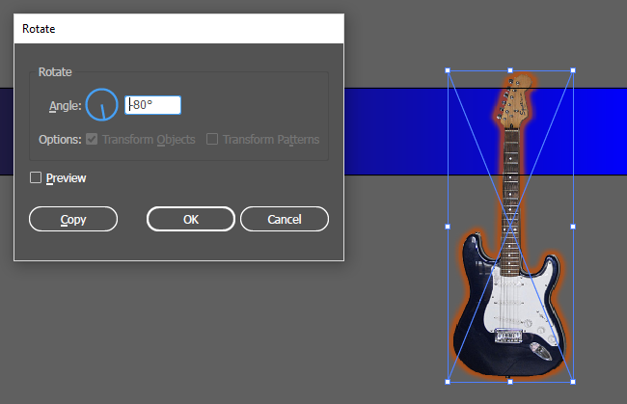

Position image where you would like it to go:

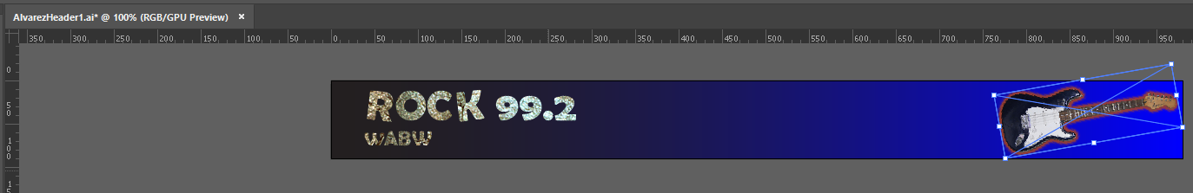

**Text:**

Create a new layer for the text and named as Type.

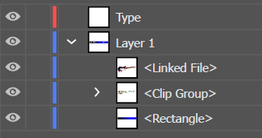

Zoom 200% and select Pen Tool(P) with stroke and fill none. Click a long straight path between two points along outside of the guitar to match the guitar angle as the guitar neck. If necessary, rotate into Object> transform > Rotate (1 degree).

Select the type on a path tool, click on the bottom of path and select a red fill and stroke none. Use Arial black and 24pt to type “Classic Rock!” Use Selection Tool(A) to reposition the text.

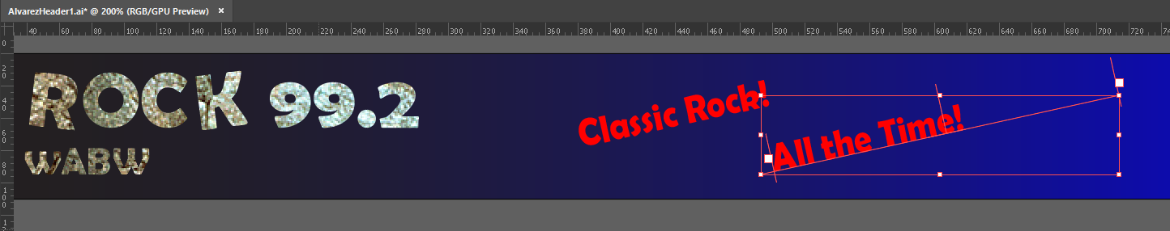

To copy of the angle line, make path line is selected and hold option/alt key dragging downward. Then select Type on a path tool to write “All the Time”. Use selection key (V) if space is necessary.

After guitar and text are positioned accurately with selection tool, select all the objects in the header and group (Object>Group).

Save document!